Dan's Corner of the Interwebz
Category: Web | Difficulty: Easy

Description
Dan's blog hasn't been updated since 2013. He says he's in "a very Chinese point in his life." Can you find his flag?
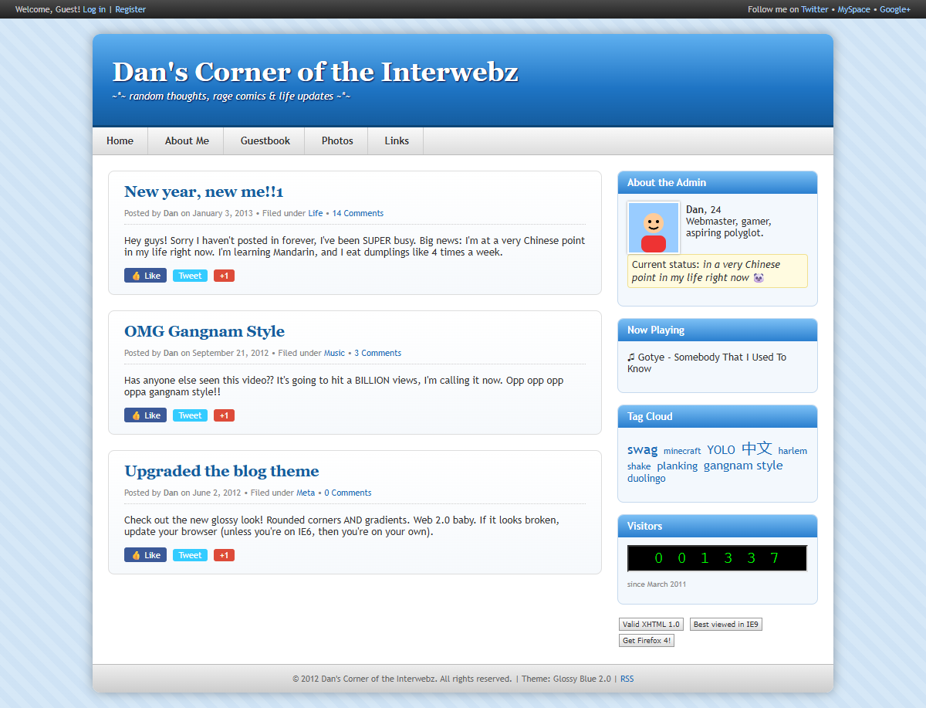
Dan's 2000s-era blog home page

Files
One hosted Docker container, built from challenge/. From that folder:
cd challenge
docker compose up --build -d # serves http://localhost:8080
The flag is supplied via the FLAG environment variable in challenge/docker-compose.yml. The app is a small Flask site (challenge/app.py) with a retro "Glossy Blue 2.0" theme; players only need the URL and a browser. The author's solution notes are in organizer/README.md.

Hint(s)
- Read Dan's posts and his profile carefully — what language has he gotten into "right now"?
- robots.txt points at /admin and /flag, but both just slam the door (403). Those are decoys.
- The site is themed around one word. How do you say "flag" in Chinese? Try visiting it as a URL path.

Walkthrough
The flag lives at a route named with the Chinese word for "flag" — the whole site is one big hint pointing at that word. The /admin and /flag paths in robots.txt are red herrings.
- Recon the blog. Dan's posts hammer the theme: *"I'm at a very Chinese point in my life right now. I'm learning Mandarin…"*, his status reads *"in a very Chinese point in my life right now,"* and the tag cloud literally includes 中文 ("Chinese language").
- Check `robots.txt`. It disallows /admin and /flag — the classic "look here" bait.

robots.txt disallows /admin and /flag
- Rule out the decoys. Visiting /admin (or /flag) just returns 403 Forbidden with a "nope" page. They lead nowhere — the hint is the *theme*, not these paths.
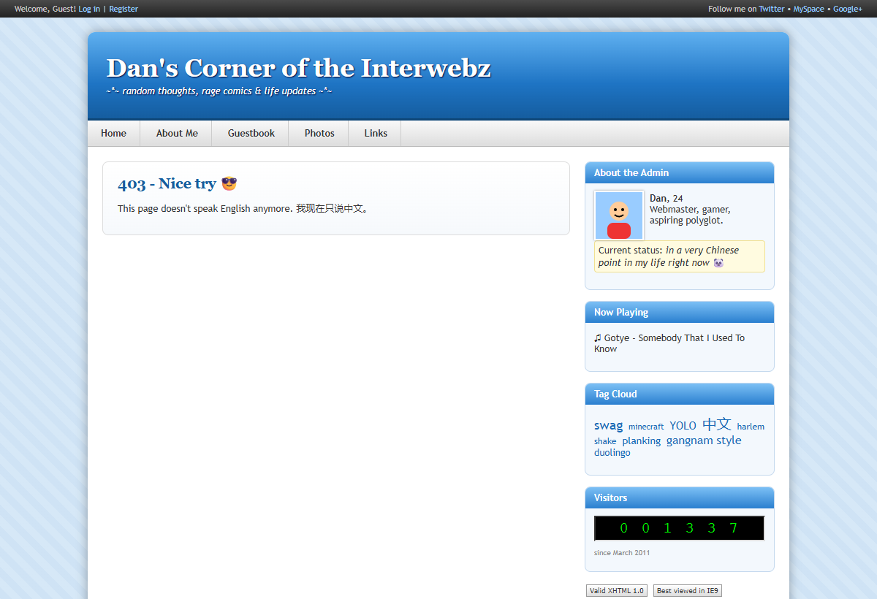
/admin is a 403 red herring
- Visit the Chinese word for "flag." The route is the Mandarin word 旗 (*qí*, "flag"), i.e. GET /旗 (URL-encoded /%E6%97%97). Several synonyms work too (旗子, 旗帜/旗幟, 国旗/國旗, 小旗, 彩旗, 旗标/旗標, 标志/標誌). The page greets you with *"你找到了我的旗子! (You found my flag!)"* and prints the flag.
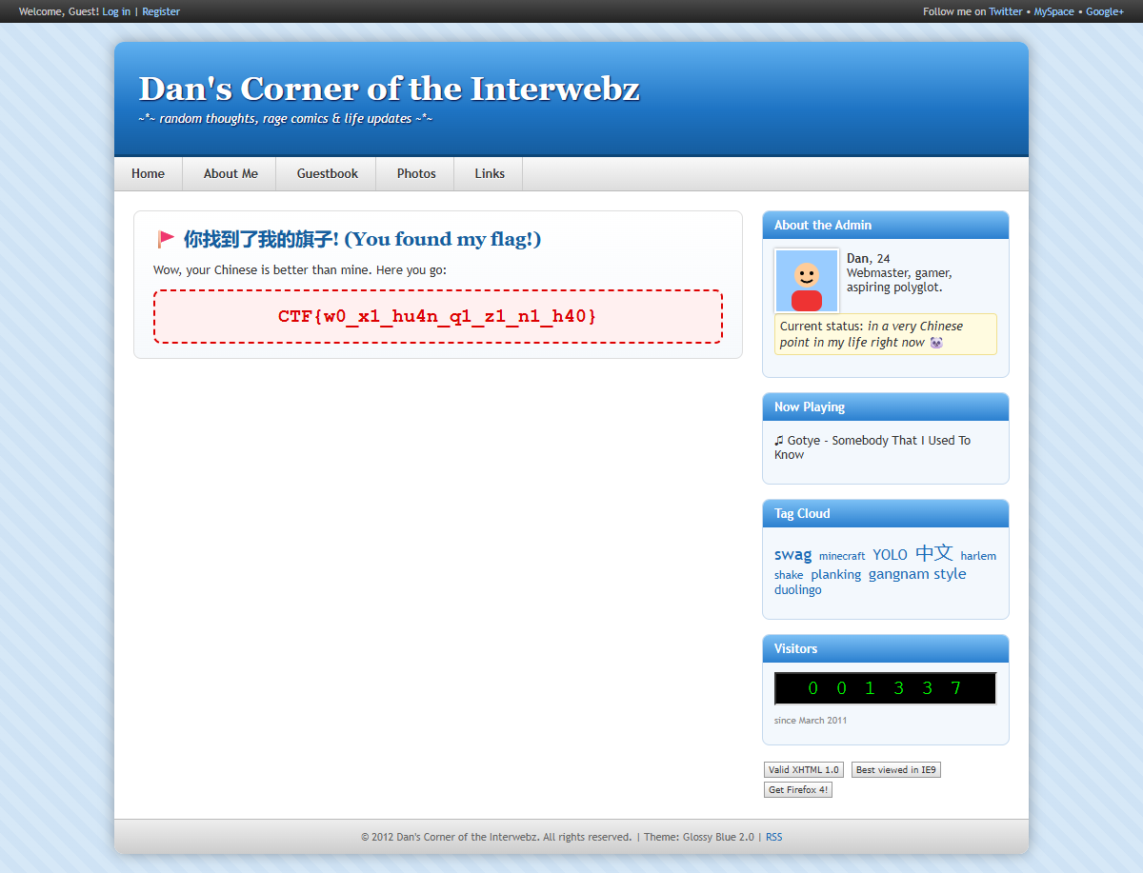
Visiting /旗 reveals the flag

Flag
CTF{w0_x1_hu4n_q1_z1_n1_h40}

